Thejasvenan T. 220638J
ME 2261 - Embedded Systems Log Book
Day 02 – 25.07.2025
Lab Practical 2
Task 1
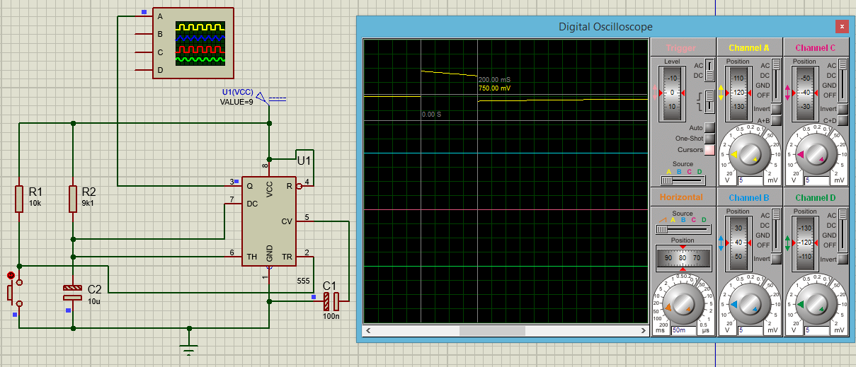
T = 1.1RC
= 1.1 x 9.1 kΩ x 10 uF
= 100.1 ms
Time period obtained in the Oscilloscope = 200 ms

Task 2
Series Parallel
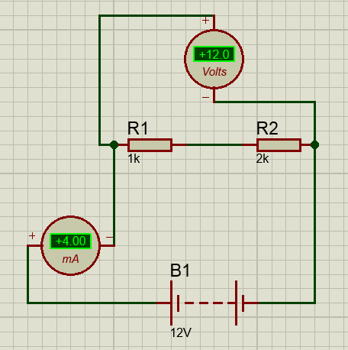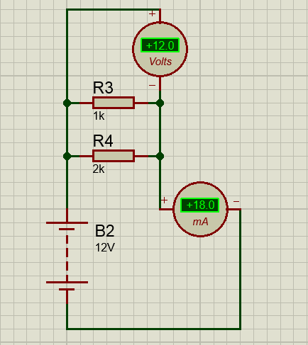
Total Resistance = V/I
In Series mode, TR = 12/4 x 10 = 3 kΩ
In Parallel mode, TR = 12/18 = 0.66 kΩ

Task 3
Charging process
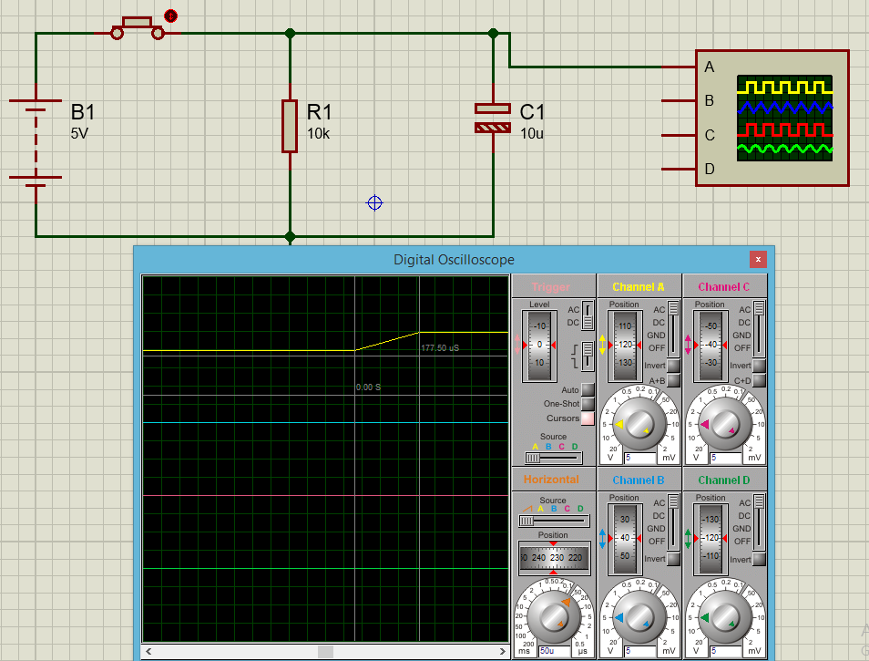
Discharging process

Task 4
Truth table
$$Y = (A∙B)+\overline{A}$$
A | B | $$A∙B$$ | $$\overline{A}$$ | $$(A∙B)+\overline{A}$$
0 | 0 | 0 | 1 | 1
0 | 1 | 0 | 1 | 1
1 | 0 | 0 | 0 | 0
1 | 1 | 1 | 0 | 1

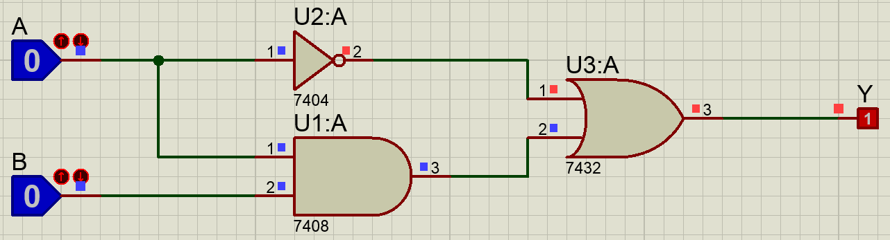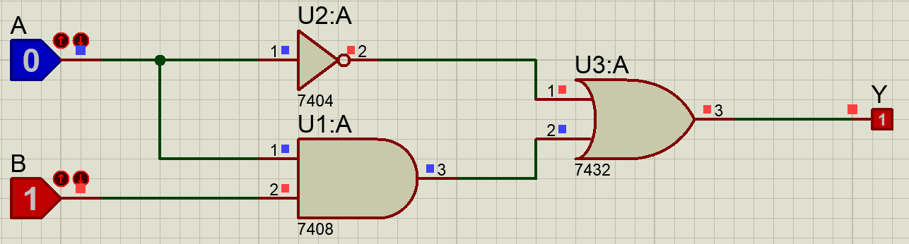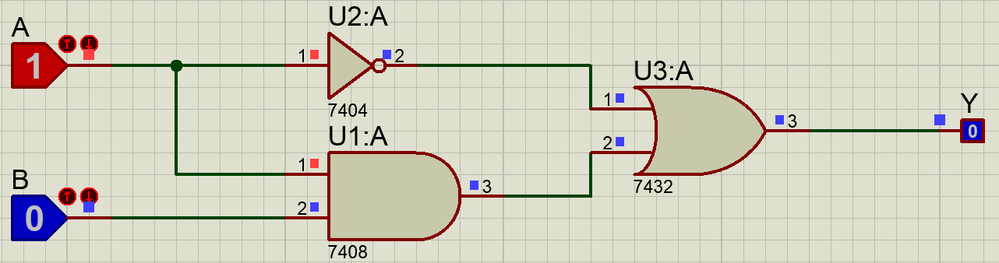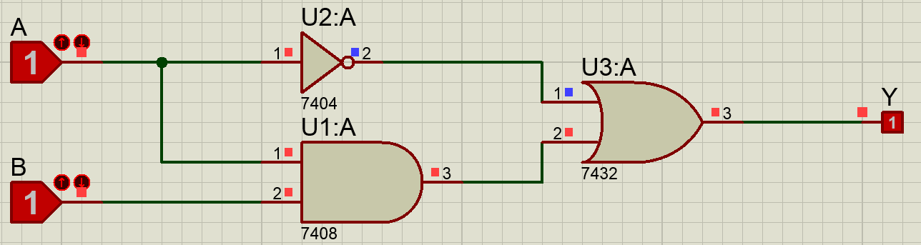
Task 5
- Pull up resistor
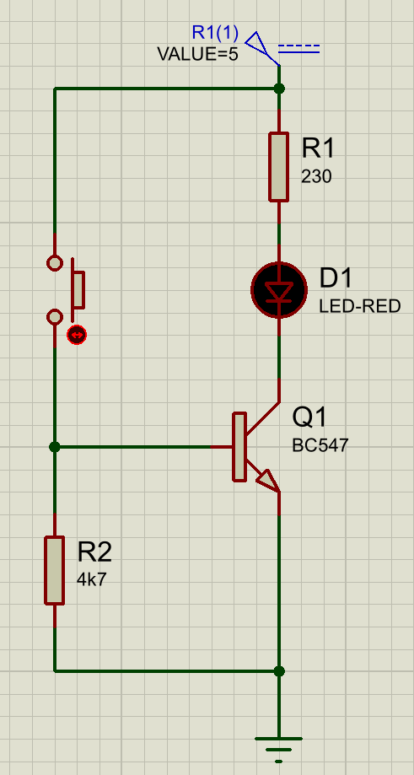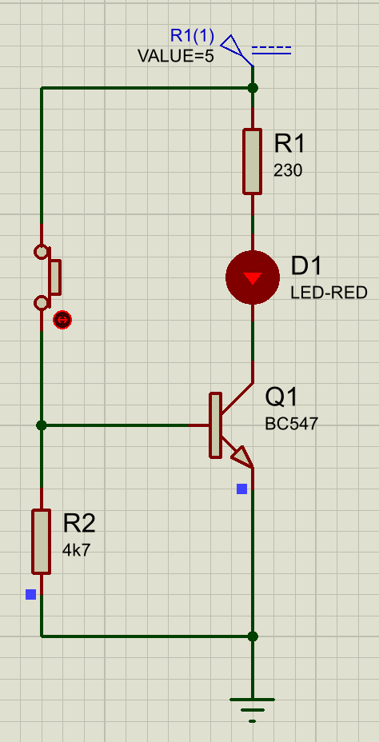

- Pull down resistor

